VGU CSE2020

Chapter 3 :

## 1. Calculate ( 123*312 +123) and print the result

## 2. Print a box unly using puts

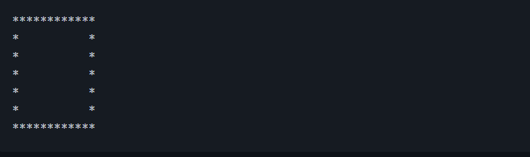

## 3. Calculate the perimeter and area of a rectangle with height = 7 (inches) and width = 5 (inches)

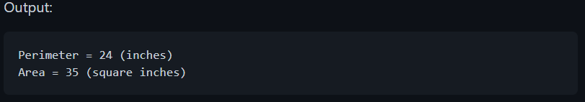

Chapter 4:

## 1. Print this text

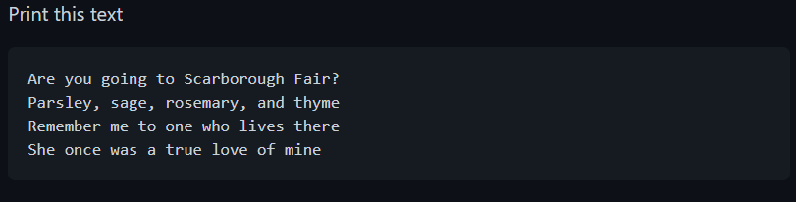

## 2. Print this without using any variable:

## "D:\[00] Upload\[00] Error\[PCCG-01351] "Shingeki no Kyojin" Original Soundtrack [24bit/48kHz].rar"

## 3. Print this table only using printf:

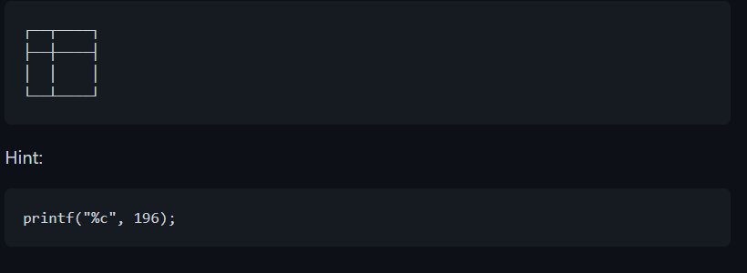

Chapter 5:

## 1. Check whetehr 23 is divisble by 4

## 2. Print these number:

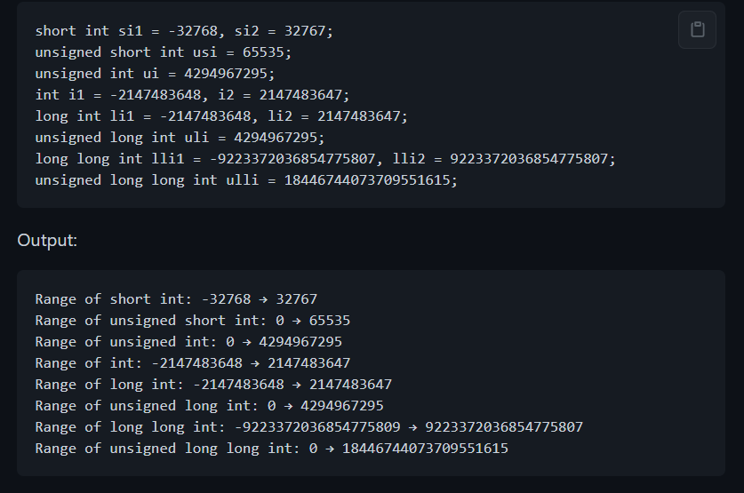

## 3. Print these number "nicely"

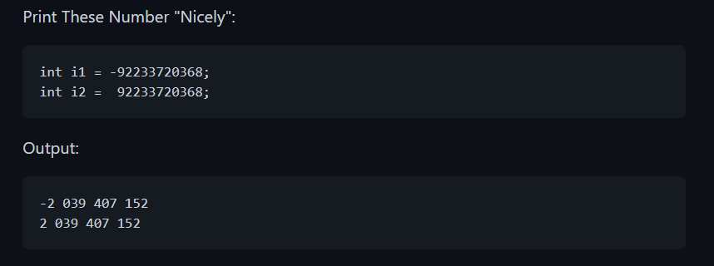

Chapter 6:

## 1.Create an array with const int type, and then try to change the value inside the array. What is the error?

## 2. Get radius from user and calculate the perimeter and area of a circle

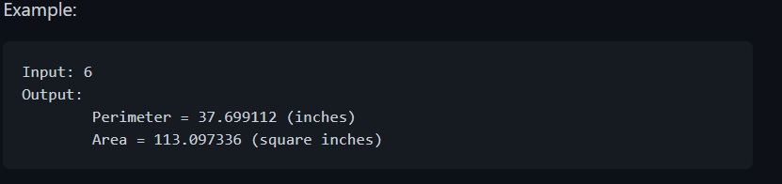

## 

Chapter 7: Input and output

# I. getchar() / getc()

## 1. Write a program using getchar() or getc() to receive a character and print the character and its integer value.

## 2. Write a program,which uses getchar() or getc(), receives 4 characters, print them and their integer value out.

# II. putchar()

## 3. Using the same idea from example at pages 86-87, create a program that prints the word "UwU"

# III. char array

## 4. write a program using fgets() to receive your date of birth, then print it out.

Chapter 8: Decision Making

## 1. Write a program to check whether a given year is a leap year or not.

## 2. Write a program to check whether a number is a multiple of 7s or not.

## 3. Write a program to check whether a number is negative, positive. Putting a different output for number 0.

## 4. Write a program to calculate the root of a quadratic equation

## 5. Write a 'guessing number' program: Every time this program runs, a random number from 0 - 10 is generated, name it the solution. The user input the same number as 'the solution' to stopped the program.

Chapter 9 :Loops

## 1. Write a program using 'for' loop to print number from 1 to 68

## 2. Write a program to display the multiplication table of a given integer

Test:

Input the number : 6

*Expected output:*

6 X 1 = 6

6 X 2 = 12

6 X 3 = 18

.

.

.

6 X 10 = 60

## 3. Write a program to display the n terms of odd number and their sum

Test Data

Input number of terms : 5

*Expected Output* :

The odd numbers are :1 3 5 7 9

The Sum of odd Natural Number upto 5 terms : 25

## 4. Write a program to make a pyramid with a number which repears the number in the same row

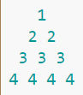

Chapter 10: Function

## 1. Write a program using *void* function to print string to the screen with your signature

* + That function should look like:

myPrintFunction("Hello World")

myPrintFunction("Nice to meet you")

* + Output:

Hello World - From Long

Nice to meet you - From Long

## 2. Write a program using function to check if a given number is even or odd

Test Data :

Input any number : 69

*Expected Output* :

The entered number is odd.

## 3. Write a program using function to swap value between a pair of variables

## 4. Write a program using function to calculate the sum of all the numbers from 1 to n

## 5. Write a program to check whether two given strings are an anagram

* + An **anagram** is a word or phrase formed by rearranging the letters of a different word or phrase, typically using all the original letters exactly once.

Test Data :

Input the first String : spare

Input the second String : pears

*Expected Output* :

spare and pears are Anagram.

Chapter 11:

## 1. What is the function of these operators ?

|  |
| --- |
| ++ |
| -- |
| += |
| -= |
| *= |
| %= |
| % |

## 2. What is the different between these two equations?

|  |  |
| --- | --- |
| a-=2021 | a=-2021 |

## 3. What do these functions do?

|  |
| --- |
| sqrt() |
| pow() |
| abs() |
| ceil() |
| floor() |

## 4. Write a program which uses your own function to calculate x raised to the power of n ( x^n)

## 5. Write a program to reverse the digits of a given integer

Example : 123 -> 321

Chapter 12: Array

## 1. From the example in page 174 of the Book, explain why array is useful in some situation

*include 
int main() 
int highscorel , highscore2,highscore3; 
printf( "Your highest score: "); 
scanf( "*d" , &highscorel ) ; 
printf( "Your second highest score: 
scanf( "*d" , &highscore2) ; 
printf( "Your third highest score: 
scanf( "*d" , &highscore3) ; 
puts("Here are your high scores"); 
, highscorel); 
printf( ":t2 ,highscore2) ; 
printf( ":t3 ,highscore3) ; 
return(e) ; 

* + Can you improve this printf() method by using array and loops ? Write a program for it

## 

## 

## 

## 2. Take a look at this code

*include 
int main() 
char sentence [ ] "Random text" ; 
int index; 
index Ø; 
putchar ( sentence [ i ndex] ) ; 
i ndex4+ ; 
put-char( ' ) ; 
return(ø) ; 

## 

## Explain the meaning of the line: while(sentence[index] != '\0'), why is it so important to determine the '\0' character of this type of array?

## 3. Write a program using fgets() that receives your name, day of birth, and your hometown then print it out to the screen.

## 4. Write a program to calculate the sum of all array elements.

## 5. Write a program in C for a two dimensional array of size nxn and print it

Chapter 13: CTYPE

# 1. Fill in the tables below

|  |  |
| --- | --- |
| **Function** | **Returns True When *a* is** |
| isalnum(a) |  |
| isalpha(a) |  |
| iscntrl(a) |  |
| isdigit(a) |  |
| isgraph(a) |  |
| islower(a) |  |
| isprint(a) |  |
| ispunct(a) |  |
| isspace(a) |  |
| isupper(a) |  |
| isxdigit(a) |  |

## 

* + What would tolower(a) and toupper(a) return ?

## 2. Create a program that converts all the upper characters of a given string to lower, all the lower characters to upper

For example:

Input : hEllo World

Output: HeLLO wORLD

## 3. Create a program that counts the number of spaces in a given sentence

For example:

Input: Hello Hello Hello

Output: 2

## 4. Create a program that concatenate two strings together

Chapter 14: Struct

# 1. Read the code below

struct record

{

char name[32];

int age;

float debt;

} bill, mary, dan, susie;

printf("Victim: %s\n",bill.name);

What is the output of this code ? Explain ? Can you fix this problem ?

## 2. Assign information of 4 records in Ex1

|  |  |  |  |  |
| --- | --- | --- | --- | --- |
|  | bill | mary | dan | susie |
| name | Bill | Mary | Dan | Susie |
| age | 20 | 21 | 22 | 23 |
| debt | 500 | 700 | 2600 | 1800 |

## 3. Create an array that stores all 4 records in Ex2

## 4. Using struct to store and compute sum of (1 meter and 50 centimeters; 1 meter and 51 centimeters)

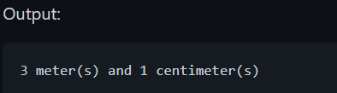

## 5.

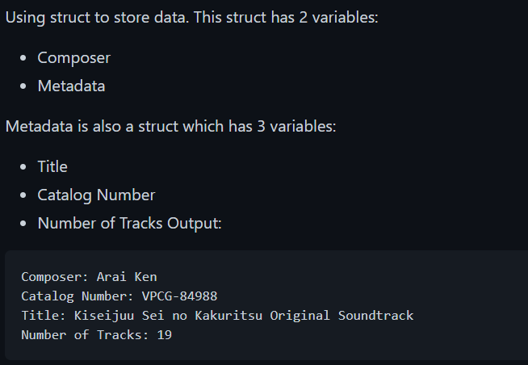

## 6.

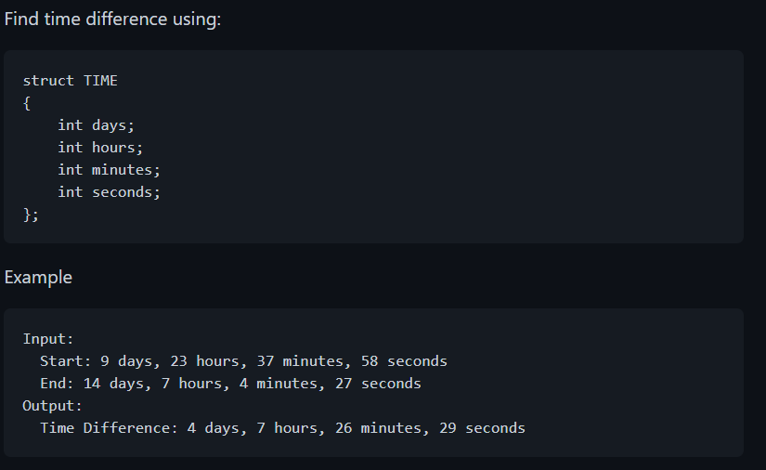

Chapter 15:

## 1. Get a list of numbers from command line and calculate sum Example:

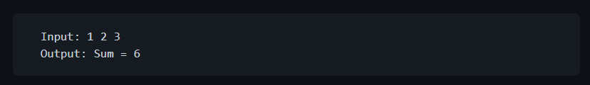

## 2. Get a list of numbers from command line and calculate Mean:

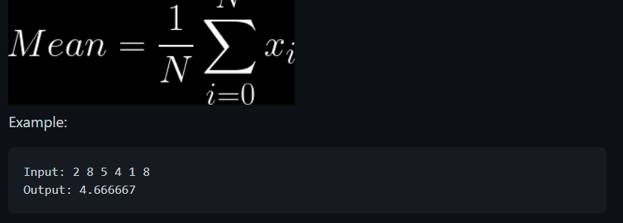

## 3. Get a list of numbers from command line and using the formula "Softmax function (stable)" to calculate:

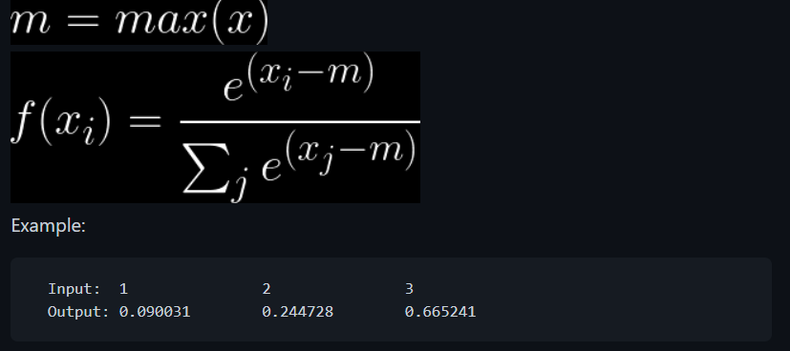

Chapter 16:

## 1. Using struct to store and compute sum of (1 meter and 50 centimeters; 1 meter and 51 centimeters) and using typedef for that struct

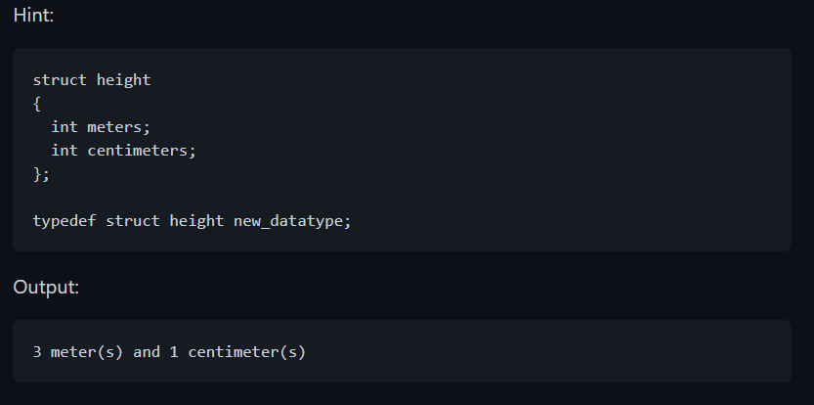

## 2. Using enumerate to store months in year 2000. Let user input a number (1-12) and then print numbers of days of that month

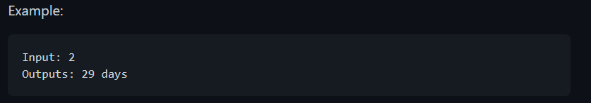

Chapter 17: Binary Mania

## Read the function below

|  |
| --- |
| Char • char  static bin(S);  for (int i —O:  bin (i J Ox20)  bin I E) 'SO',  re turn |

## 

## 1 - Based on the binbin() function, write a binbin() function for integer number.

## unsigned char -> 8 bits then int -> 4 bytes -> 32 bits

## 2 - Based on the binbin() function, write a function to check whether an integer number is a power of 2 or not.

## Using &

## 3 - Base on the OR bitwise, NOT bitwise and the source code in the textbook, write a function to convert lowercase letter to upper case letter.

## Using |, ~

## 4: Write a function to print an integer number to hexadecimal number. Use the stdin to get the input number

## 

## 5: Write a function Multiplier(int number, int power), which will return the result of the multiplication between the input number and a power of 2

Chapter 18: Introduction to Pointer

## 1: Define 3 variables, 1 int, 1 double and 1 char, then print the size of each variable.

## // Using sizeof() function

## 

## 2: Use strlen() and sizeof() to get the length of a string. Explain the result, by comment.

## 3: Define a variable a = 10. Change the value in a to 100 by 2 ways.

## 4: Create an array of integer numbers. Print the address of its elements in a row.

## //Defind a pointer pointing to array[3] and a pointer pointing to array[4]

## //Increase the pointer pointing array[3] by 1. Comment.

## 5: Define an array of integer numbers. Write a code to get the length of the array.

Chapter 19: Deep into Pointer Land

## 1: Define a variable a = 10. Write 2 VOID functions to increase value of a by 1. Print a once again.

## //2 Ways: Using variable - Using pointer

## 2: Define an array of integer numbers. Define a pointer *p pointing to that array. Print the elements of the array using *p

## 3: Define an array of pointers, where each element is a string with length at least 2. Print the second character of each string

## 4: Define a void function named ExchangeUsd2Vnd(double* money). This function will take a double type pointer as argument. The

## //function will convert the money in Usd to Vnd. Note: Vnd = Usd*23

Chapter 20: MemoryChunkand LinkedList

## 1: Define a pointer name p. Now use p to store number from 0 to 9. Print the numbers. Hint: Use malloc() to allocate a buffer

## //for p to point to

## 2: Exercise 20-2 in Textbook.

## 3: From EX1, realloc the buffer so that p can hold up to 20 numbers.

Chapter 21: Its about time

## 1: Exercise 21-4: Write code that passes the time_t value 946684800 to the ctime() function. Output the string that’s returned.

## 2:Exercise 21-7: Write code that outputs the current time in the format hour:minute:second. Ensure that the minute-and-second output is two digits

## 3:Exercise 21-8: Fix your solution from Exercise 21-7 so that the output is in 12-hour format with an A.M. or P.M. suffix based on the time of day.

## 4: Modify the code in listing 21-3 so that the code print the correct year.

Chapter 22: Permanent Storage

## 1: Write a line "Hello World" to file hello.txt.

## 2: Read data from file hello.txt and print it to the screen.

## 3: Based on READ and WRITE functions, write a code for copying file hello.txt to hello_copied.txt.

## 4: Write a code to check whether 2 files are the similar or not.

## 5: File dumper: Write a code to print the file hello.txt into a matrix of width 5, in hexadecimal form.

Chapter 23: File Handling

## 1.Write a program in C to create and store information in a text file

## 2. Write a program in C to read an existing file.

## 3. Write a program in C to write multiple lines in a text file.

## 4. Write a program in C to find the content of the file and number of lines in a Text File.